Lewis Dot Symbols and Bonding
Gp (A) | 1 | 2 | 3 | 4 | 5 | 6 | 7 | 8
element | Li | Be | B | C | N | O | F | Ne
# outer shell e | 1 | 2 | 3 | 4 | 5 | 6 | 7 | 8
Element  Dot symbol |  |  | 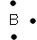 | 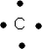 | 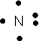 | 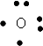 | 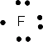 | 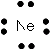
Compound  Dot  symbol | 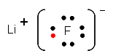 | 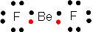 | 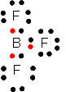 | 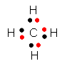 | 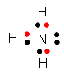 | 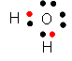 | 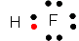 | none
Line Drawing | . | 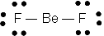 | 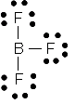 | 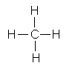 | 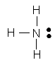 | 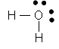 | 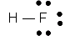 | .
# covalent bonds | (ionic bond) | 2  (Be e⁻ deficient) | 3  ( B e⁻deficient) | 4 | 3 | 2 | 1 | 0

