Kocherlakota takes on the hottest controversy in monetary policy
By Louis D. Johnston | 01/06/15
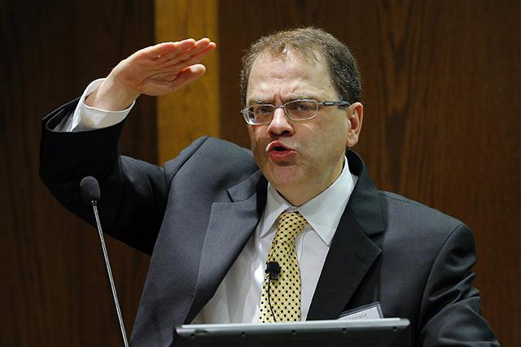
REUTERS/Brian Snyder
President Kocherlakota thus continues to play an important role both in formulating current U.S. monetary policy and in setting the research agenda for macroeconomists.
Narayana Kocherlakota, president of the Federal Reserve Bank of Minneapolis, does not intend to leave his position quietly. He made that clear on Saturday at American Economic Association meetings in Boston when he took on one of the biggest issues in macroeconomic policy: the degree to which central banks should have discretion in monetary policy.
To understand what a big deal this is, you need to understand that for many years economists promoted the superiority of economic policymaking based on clearly stated rules instead of allowing policymakers discretion in matters such as setting interest rates. This point of view originated with economists associated with the Minneapolis Fed starting in the 1970s. In his talk, Kocherlakota directly challenged this line of thinking.

Monetary policy rules
The consensus among economists that evolved over the past twenty-five years is that monetary policy (i.e. setting the level of short-term interest rates and thus affecting the entire range of interest rates in the economy) should follow clear, predictable rules. These rules should only be violated in extraordinary circumstances. Of course, there were disagreements about what constituted extraordinary circumstances — a financial crisis like that of September 2008 clearly fit the bill, but other cases, such as the possibility of deflation in the early 2000s, were murkier.
The best current example of a monetary policy rule is the Taylor Rule, named for John B. Taylor of Stanford University. To follow the Taylor Rule, a central bank chooses a target rate of inflation (usually around 2 percent) and estimates the economy’s level of potential output, then sets its short-term interest rate at a level that keeps actual inflation as close as possible to the inflation target and the economy’s real GDP as close to potential output as possible.
In practice, this rule tells a central bank to increase interest rates when inflation rises and/or when GDP is above potential and to cut interest rates when inflation falls and/or when GDP falls below potential.
The Federal Reserve does not explicitly follow the Taylor Rule but by and large macroeconomists find that it explains the Fed’s behavior quite well since the mid-1980s. One exception is when the Fed kept interest rates below the level predicted by the original Taylor Rule in the early 2000s and Taylor himself has argued that this contributed to the housing bubble of 1999 to 2006.

Rules, discretion, and the Great Moderation
There are two reasons for the widespread acceptance of monetary policy rules as superior to allowing central banks wide discretion in setting interest rates. One is theoretical, the other historical.
The theoretical case was first made in 1977 by two economists who for many years have been affiliated with the Minneapolis Fed, Finn Kydland and Edward Prescott. Their paper, “Rules Rather than Discretion: The Inconsistency of Optimal Plans,” set the terms of the debate for the next thirty years and led to their 2004 Nobel Prize. The paper is full of dense mathematics but the authors make their point clearly near the end of the paper: “The reason that [central banks] should not have discretion is not that they are stupid or evil but, rather, that discretion implies selecting the decision which is best, given the current situation. Such behavior either results in consistent but suboptimal planning or in economic instability.”
Economic instability was all around in the late 1970s, with both inflation and unemployment at high and rising rates. The time was ripe for a natural experiment and history now provided one. Starting in the mid-1980s, inflation rates fell throughout the industrialized world and stayed below their 1970s levels for the next twenty years. Unemployment fell as well, more so in the US than in Europe. This period thus came to be known among economists as the Great Moderation.
So, what caused the Great Moderation? One hypothesis, proposed by 2011 Nobel Laureate (and former University of Minnesota and Minneapolis Fed advisor) Thomas Sargent was that the movement by governments away from the kinds of discretionary policies they followed from the mid-1960s until the early 1980s and towards rules-based policies such as the Taylor Rule promoted economic stability and the Great Moderation. Discretion led to economic instability (see the 1960s and 1970s) while rules-based policy promoted stability (see the 1980s, 1990s, and early 2000s.)
Thus, the evidence seemed to support out Kydland and Prescott’s theory. Or did it?
Throughout the Great Moderation there were economists who pointed to an equally likely possibility: that we were lucky and that since the mid-1980s the industrialized world had not experienced any violent economic shocks such as the rapid increases in oil prices seen in the 1970s or the financial crises of the 1930s. They pointed to the period 1880 to 1914, when a period of relative stability was often attributed to the benefits of following the rules of the gold standard but was actually the result of a convergence of a variety of favorable economic factors unrelated to monetary policy. They warned that policymakers and economists were mistaking luck for virtue.

Enter Kocherlakota
The financial crises of 2007-2008 and the Great Recession convinced many economists that good luck was far more important to the Great Moderation than were the adoption of monetary rules. This hasn’t shaken the theoretical case for rules instead of discretion, however, and this is where President Kocherlakota’s recent talk enters the picture. Rather than simply appealing to recent history, Kocherlakota took on the rules versus discretion topic from a theoretical perspective in light of that history.
Kocherlakota presented a theoretical model and applied it to five hypothetical cases in order to make his point. His main point is that recent history clearly demonstrates that the Federal Reserve is biased against letting inflation get out of control. When we build this into our models, and knowing from his experience as a Fed President that policymakers rely “in a complex way, on many indicators of inflationary pressures,” the model suggests that “in the US, discretion is better than any rule.”
For a concrete example of this, think back to the economic expansion of the mid-1990s. The standard economic measures were saying that actual output was close to potential output, creating the danger of inflation. Strict adherence to the Taylor Rule would have required that Fed policymakers raise interest rates. But Fed Chair Alan Greenspan knew the underlying economic data better than anyone and was convinced that, because of the IT revolution, potential output was actually much high than what was indicated by standard measures, and therefore the risk of inflation was actually quite low. Greenspan was able to convince his colleagues not to raise interest rates, and this move likely kept the economic expansion of the 1990s going longer than it otherwise would have.
With Kocherlakota’s Boston speech, the battle has been joined. The rules versus discretion argument is now alive on both the empirical and [theoretical] fronts.
If you think this is all an esoteric argument among economists, think again. This past summer Congress held hearings on a bill that would require the Fed to follow the Taylor Rule. The assumption seems to be that we would have done better since 2008 had Ben Bernanke and his colleagues been constrained in their actions rather than being allowed to do “whatever it takes,” to quote Bernanke.
President Kocherlakota thus continues to play an important role both in formulating current U.S. monetary policy and in setting the research agenda for macroeconomists. There’s certainly gnashing of teeth in some quarters at Kocherlakota’s willingness to challenge the Minneapolis Fed’s research heritage, but I for one look forward to hearing more from the president during his last months in office.

