 July Term 2008

India-Nepal-Tibetsssss

Departing July 15

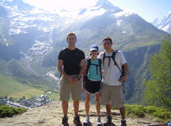 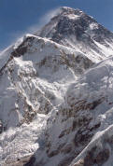

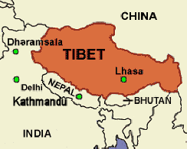 

Picture yourself in the magnificent scenery of the Himalayas, talking to local people, enjoying the rich food and drink of the local cultures, hiking, and visiting major Buddhist monasteries. In Delhi you will visit the Gandhi memorial and other sacred sights.

In Dharamsala you will visit the monastery of the Dalai Lama, a most important world religious leader.  You will meet monks your age and interview them about their experiences and tell them about yours. This is the 5-day service and research aspect of the trip.

In Katmandu (Nepal) and Lhasa (Tibet) you will experience Himalayan life first hand. In the evenings we will gather for good food at a local restaurant and talk about our day's experiences.  You will also be able to meet students your age from all over the world. Join us for the trip of your life!

*If you are interested, take this brochure home with you!*

Tibet & Mount Everest Base Camp - This July!

feel free to take this brochure home



The final days of our trip we will   
explore Tibet in all its wonders!

Actual cost per participant $6100

Because of a grant given to the

Saint John's Men's Center,

many costs will be paid,

bringing the cost per participant to   
about $4100*

*($4900 without the grant)*

 

**\*Do you want the $800 grant? Do this:**

1. Be one of the first 12 to make a deposit of $200;

2. Complete a 5-day service component interviewing young Buddhist monks and speaking English with them

3. Write up your research findings.

4. Contribute daily to the upbeat ethos of the group.



Men's Center

July Term 2008

The Sacred Heights   
of the Himalayas - Join us!  
  
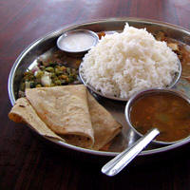 

Work hard at your summer job the first eight weeks of summer, then **take the last four weeks to experience the breathtaking cultures and beauties of the top of the world** -- with an amazing group of students.



Take advantage of our first-ever grant to cover major trip expenses to the great Himalayan sites, bringing each participants costs down by an average of almost $2000.

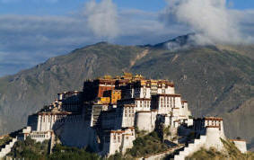 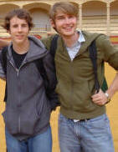

For the full website information,

Google Mark Thamert Homepage

and find the July Term Link.  
Easy on-line application

This trip is made possible through a Lilly Foundation grant to the **Saint John's University Men's Center** and through the expert planning and vision of Gar Kellom, SJU Vice President for Student Development and Director of the Saint John's University Men's Center.

*Email mthamert for more info*