Revised Schedule
Chem 125 Fall 2014

Monday, Nov 10th
Preparation:
- Read: Structure & Reactivity: MO15
- Videos:
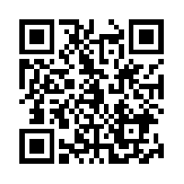
  - Video: Conjugated Alkene Orbital Systems

- Suggested Practice Problems:
  - Structure & Reactivity: MO14.1-14.5, IM6.1-6.6

In class:
- SNOW Day

Tuesday, Nov 11th 6:30-8:00 pm Faculty Tutorial Session, O’Connell’s Coffee Shop

Wednesday, Nov 12th
Preparation:
- Read: Structure & Reactivity: MO16-17

- Suggested Practice Problems:
  - Structure & Reactivity: MO15.1-15.3

- Homework due:
  - Group Assignment: Resonance, Wkbk, 398-400
  - Passport: MO of conjugated systems, Wkbk, 402-403

In class: Structure of Conjugated Systems
- Socrative Quiz (5 pts): Conjugation and Resonance
- MO of conjugation, Workbook: 403-404
- Properties of Conjugated Compounds, Workbook: 406-408

Friday, Nov 14th
Preparation:
- Read: Structure & Reactivity: MO16-17
- Videos:
  - Video: Huckel molecular orbital diagrams (click for link)

  - Video: Aromatic and antiaromatic compounds

- Suggested Practice Problems:
  - Structure & Reactivity: MO14.6, MO15.4
  - Conjugation Summary, Workbook, 409
  - Application Problems, Workbook: 410-411

- Homework due:
  - Sapling: Hybridization, Resonance & Conjugation
  - Group Assignment: Conjugation Applications, 410-411

In class: Structure and Properties of Aromatic Systems
- Short Problem Solving Assessment #13: Conjugation and Resonance
- Aromaticity, Workbook: 416-422

Monday, Nov 17th
Preparation:
- Suggested Practice Problems:
  - Structure & Reactivity: MO16.2, MO16.5, MO17.1-17.2
  - Aromaticity Summary, Workbook, 419

- Homework due:
  - Passport: Determining Aromaticity, Workbook, 423
  - Group Assignment: Band Theory, Workbook, 441-451
    - OR UV, Workbook, 452-455

In class: Structure and Properties of Aromatic Systems
- Socrative Quiz (5 pts): Aromaticity
- Aromaticity Applications, Workbook: 423-431
- Orbital Patterns, Workbook: 436-440

Tuesday, Nov 18th 6:30-8:00 pm Faculty Tutorial Session, O’Connell’s Coffee Shop

Acids and Bases

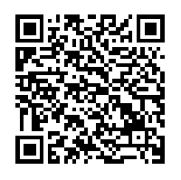
Wednesday, Nov 19th
Preparation:
- Read: Structure & Reactivity: AB1-6

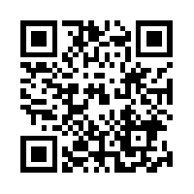
- Videos:
  - Video: Bronsted and Lewis Acid/Base Theory (click for link)

- Suggested Practice Problems:
  - Structure & Reactivity: MO16.2, MO16.5, MO17.1-17.2

- Homework due:
  - Moodle: Chem Tutor: 10.1, 10.2
  - Passport: MO Patterns, Workbook, 436-440
  - Sapling: Aromaticity

In class: Introduction to Lewis Acids and Bases
- Short Problem Solving Assessment #14: Aromaticity
- Socrative Quiz (5 pts): Lewis Acid-Base
- Lewis Acids & Bases and Arrows, Workbook, 456-459

Friday, Nov 21st
Preparation:
- Read: Structure & Reactivity: AB6-9

- Suggested Practice Problems:
  - Structure & Reactivity: AB2.1, 3.1, 4.2-4.5, 6.1, 6.2, 6.3

- Homework due:
  - Moodle: Chem Tutor: 10.3

In class: Introduction to Bronsted Acids and Bases
- Socrative Quiz (5 pts): Bronsted Acid-Base
- Bronsted Acid/Base and Arrows, Workbook, 460-465

Monday, Nov 24th
Preparation:
- Read: Structure & Reactivity: AB10-13

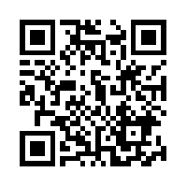
- Videos:
  - Video: Inductive effect (click for link)
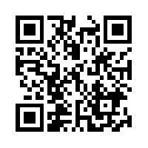
  - Video: Effect of size (click for link)
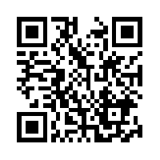
  - Video: Effect of resonance (click for link)

- Suggested Practice Problems:
  - Structure & Reactivity: AB 7.1, 8.1-8.4, 9.2

- Homework due:
  - Passport: Acid Base, Workbook, 450-451
  - Sapling: Acid-Base Intro

In class: Proton Transfers
- Short Problem Solving Assessment #15: Lewis A/B
- Which Proton? How Easily?, 466-467
- Structural Features of Acidity, Workbook, 468

Tuesday, Nov 25th No Faculty Tutorial Session

Wednesday, Nov 26th –Nov 30th
Thanksgiving Weekend
Monday, Dec 1st
Preparation:
- Read: Structure & Reactivity: AB14-17

- Suggested Practice Problems:
  - Structure & Reactivity: AB11.1-11.3, 12.1-12.4, MO16.4
- Applications, Workbook 456-461, 470-475
- Basicity, Workbook, 476

- Homework due:
  - Group Assignment: “What’s the Most Acidic Proton?”

In class: Proton Transfers
- Socrative Quiz (5 pts): Most Acidic Proton
- Socrative Quiz (5 pts): Strength of Bases
- Applications
  - Workbook 456-461, 470-475
- Basicity
  - Workbook, 476
- Problem Solving Assessment #16: Proton Transfers

Tuesday, Dec 2nd 6:30-8:00 pm LAST Faculty Tutorial Session, O’Connell’s Coffee Shop

Wednesday, Dec 3rd
Preparation:
- Read: Structure & Reactivity: AB9, 14

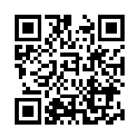
- Videos:

  - Video: Predicting Products

  - Video: Using pKa to Predict Direction

- Suggested Practice Problems:
  - Structure & Reactivity: AB9.2, 14.1

- Homework due:
  - Sapling: Structural Basis for Acid Base Chemistry

In class: Equilibria
- Socrative Quiz (5 pts): Equilibria
- Introduction to Equilibria and Predicting Direction of Reaction
  - Workbook 478-480
- Leveling Effect
  - Workbook 481-483

Friday, Dec 5th
Preparation:
- Read: Structure & Reactivity: AB15-18

- Videos:
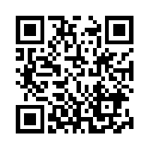
  - Video: Acid-Base Extractions (click to link)

- Suggested Practice Problems:
  - Structure & Reactivity: AB15.1-15.7, 17.1-17.6

- Homework due:
  - Sapling: Acid-Base Equilibrium

In class: Equilibria
- Socrative Quiz (5 pts): Extractions
- Applications of Acid-Base
  - Workbook 485, 490
- Acid-Base Extraction
  - Workbook 486-489
- Cumulative problems
  - Methane Monooxygenase, Workbook, 499-505
  - Amide Cumulative Problem Workbook 510-517
  - Nanoparticles for Drug Delivery, Workbook, 506-509

Monday, Dec 8th
Preparation:
- Homework due:
  - Group Homework: Electrophoresis, Workbook, 491-494
  - Sapling: Acid Base of Biomolecules

In class: Equilibria
- Problem Solving Assessment #17: Application Problem

Wednesday, Dec 10th
Study Day
- SALG

- Student Evaluations

- Practice for Final!
  - Multiple Choice Practice can be downloaded from Sapling
  - Extra Sapling Practice
  - Lookover PSAs, Homeworks
  - Do suggested problems from texts (answers are available)

Final Exam
8:15-10:15 Thursday, December 11th (Graham)
55 Multiple Choice Questions

CSB/SJU Final Exam Schedule:
http://www.csbsju.edu/Documents/Registrar/terms/144/144_FinalsSchedule.pdf

